

*Department of Computer Science and Engineering*

United International University

|  |  |  |  |  |
| --- | --- | --- | --- | --- |
| **SL** | **ID** | **Section** |  | **Name** |
| **1** | 011143036 | SE |  | Muhammad Makama Mahmudur RahamanOhee |
| **2** | 011143080 | SE |  | Md. Bayzid Rahaman |

*Team Members*

*Project Name:*

*ATM System Management*

*Team ID: ATM Booth*

*Project Report:*

*Advanced Object Oriented Programming*

*Summer - 2016*

# Introduction

The main objective of the project is to develop online Banking system for banks. In present system all banking work is done manually. User have to visit bank to  Withdraw or Deposit amount. In present bank system it is also difficult to find account information of account holder. In this bank management system we will automate all the banking process. In our bank management system user can check his balance online and he can also transfer money to other account online. In this Software you can keep record for daily Banking transactions. The main purpose of developing bank management system is to design an application, which could store bank  data and provide an interface for retrieving customer related details with 100% accuracy.

This bank management system also allow user to add new customer account ,user can also modify existing user account information. Using this system user can also search any individual account in few seconds. Using our bank management system user can also check any translation in any account. Our system also provide security check to reduce fraud. The system will check the user’s existence in the File and provide the set of services with respect to the role of the user.

# Motivation

# *To create a user friendly ATM Booth.*

# Project Features

# *1. Easy Create Account: This Feature contains to create account as easy as possible.*

# *2. Balance Transfer: Easily transfer balance one account to another account. Just needed two id to transfer.*

# *3. Easy Sign In: Online easy sign in feature.*

# *4. Deposit: This Feature contains easy deposit money in customer account.*

# *5. Withdraw: withdraw money as easy as possible.*

# *6. Account Information: Customer can know about his account.*

# Platform, Library & Tools

# *Platform: *Windows*

# *Language: *JAVA (Awt, Swing)*

# *Supporting Software: *IntelliJ IDEA, NetBeans*

# Limitations

# *Limitation: Forgetting Password or pin number can’t access account.*

# *Failed to Achieve: Balance Transfer.*

# Screenshots

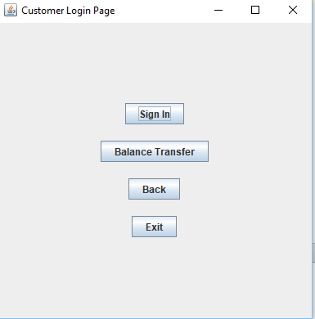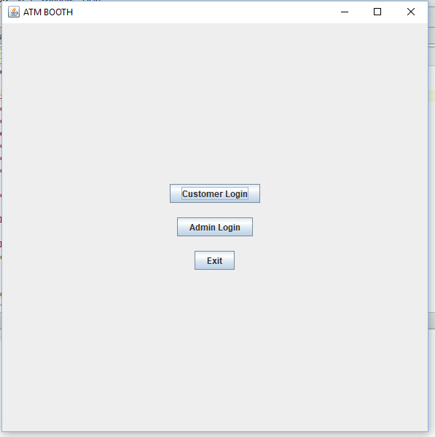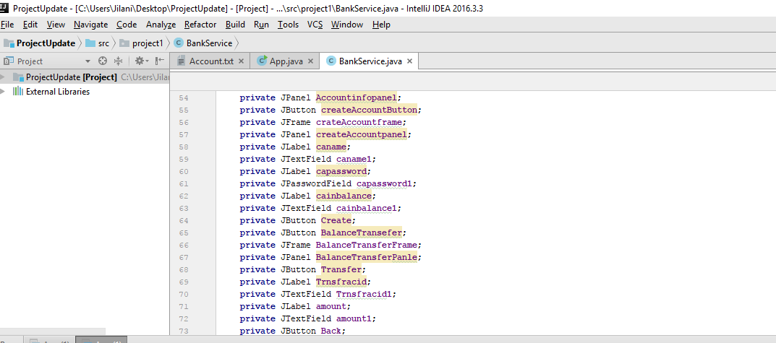

# Conclusions

# *Learn a lot from this project. Using File and Swing makes a great experience. This project is a short form of ATM system.*

# Future plan

# *To include some features. Like Edit password, Cash Out, Card Transaction, Maximum deposit or withdrawal etc. Change Layout and make it Attractive.*

# *References*

##### *Course Teacher, Google, Youtube*